**Lab 6: Sequential Circuit Design**

**Primary Objectives**

1. Design state and timing diagrams for state machine

2. Create state assignments and state table

3. Implement the system using the Logisim software

*Objective 1 Design*

This system is supposed to take a spinning disk with one black half and white and determine if it is spinning clockwise or counterclockwise using two probes, A and B, located at 12 o’clock and 3 o’clock on the disk, respectively. These probes will each be an input in the system. The probes should register a 1 when the black part of the disk is under it and a 0 when the white part is under it. The probes will only register values when a third input, ENABLE, is on. There are also two outputs, DIRECTION and VALID. DIRECTION is 1 if the disk is spinning clockwise and 0 if the disk is spinning counterclockwise. VALID is 1 if and only if the direction of the disk’s rotation is determined. A state diagram of the system is shown below.

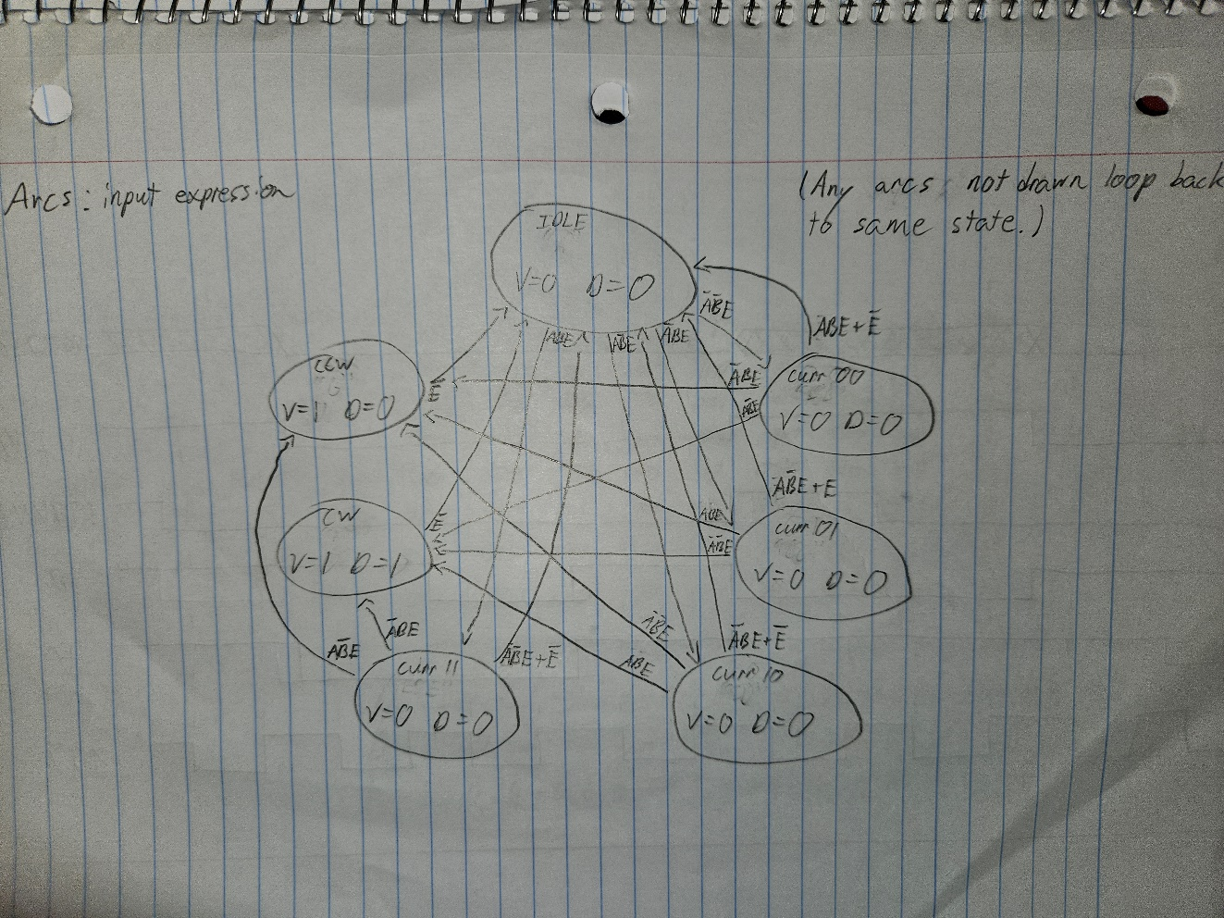

State Diagram

There are seven states in this machine: IDLE, curr00, curr01, curr10, curr11, CW, and CCW. IDLE is the default state which the machine returns to if ENABLE turns to 0 or an impossible state is somehow reached. Curr00, curr01, curr10, and curr11 represent the status of the A and B inputs when ENABLE is initially turned to 1 from the IDLE state. Each of these states will then progress to either CW (clockwise) or CCW (counterclockwise), depending on whether A or B changes values first, which determines the direction the disk is spinning. Below is a timing diagram representing what a sample of inputs would look like during eight cycles of the clock.

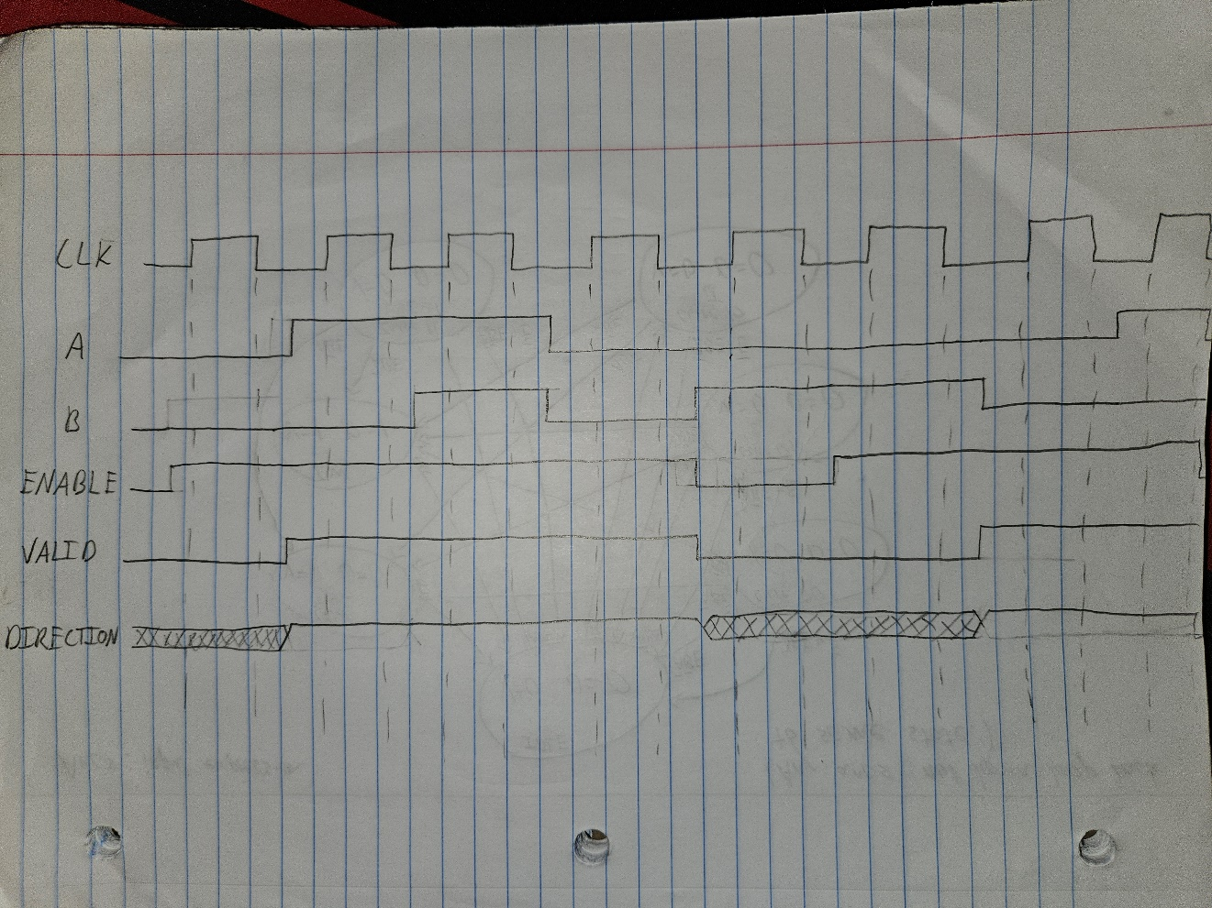

Timing Diagram

*Objective 2 State Assignment*

Shown below are the state assignments, state table, and excitation equations for the sequential circuit.

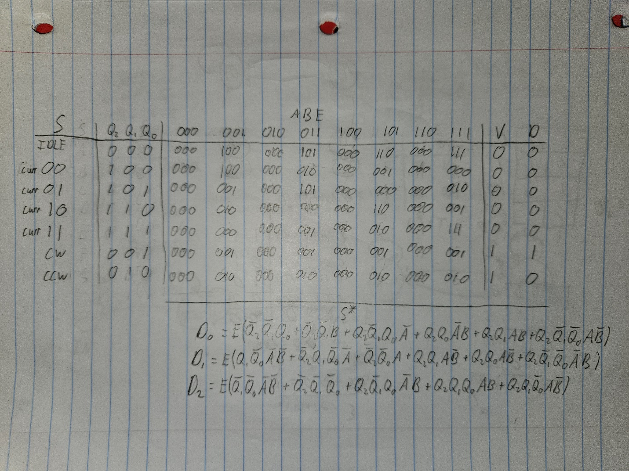

State Table

The IDLE state was simply labeled as 000 since this is the default state the system returns to when ENABLE is 0 or something goes unexpectedly wrong. The curr00 – curr11 states were label with Q2 as 1 and Q1Q0 matching the current values of A and B in the corresponding state. CW and CCW were labeled with only a single 1 in each assignment, denoting the direction of rotation. The excitation equations were calculated and simplified using k-maps for Q2*, Q1*, and Q0*. Note that E (ENABLE) is factored out of each equation, showing that D2, D1, and D0 cannot ever be turned on without ENABLE being 1.

*Objective 3 Implementation*

Shown below is the implementation of the sequential circuit in Logisim.

System Implementation